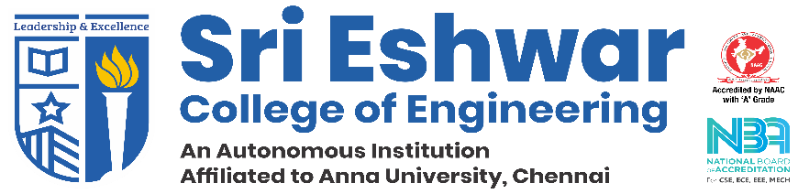

**Innovative Project Report (2019-2020)**

**Date of presentation: 29-02-2020**

**Department: Class:**

|  |  |  |  |  |  |
| --- | --- | --- | --- | --- | --- |
| **1.** | **Name of the Project Mentor: Mr.Sampath Kumar S** | | | | **Position:** Assistant Professor |
| **2.** | **Team Name: Smiling Stars** | | | | |
| **3.** | **Student Innovators Details:** | | | | |
| **Roll Number** | **Name** | **Scope of work** | | |
| 18cs013 | Arun Nataraj S | Chatbot Developer | | |
| 18cs017 | Avinash | Webpage Developer | | |
| 18cs028 | Devasarathy B | Requirement Gathering | | |
| 18cs048 | Jagathishprabu S | Dictionary Developer | | |
| **4.** | **Project Title: Lakmé** | | | | |
| **5.** | **Field / Thrust Area: CLOUD** | | | **6.** | **Total Budget (**http://www.blogcdn.com/www.coolage.in/media/2011/06/rupee-symbol.jpg**): 15,000 /-** |
| **7.** | **Abstract of the Innovative project report:**  Chatbots, or conversational interfaces as they are also known, present a new way for individuals to interact with computer systems.Traditionally, to get a question answered by a software program involved using a search engine, or filling out a form.A chatbot allows a user to simply ask questions in the same manner that they would address a human. Chatbots are currently being adopted at a high rate on computer chat platforms.The technology at the core of the rise of the chatbot is Natural Language Processing (“NLP”).Recent advances in machine learning have greatly improved the accuracy and effectiveness of natural language processing, making chatbots a viable option for many organizations. **Keywords**: ChatBot, NLP, Machine Learning, Conversational System, | | | | |
| **8.** | **The importance and benefits of the innovative project to the society:**  *1) The chatbots cuts down the operational cost*  *2) User-Friendly and easy access of database.*  *3) 24 / 7 service.* | | | | |
| **9.** | **Paste photographs of the project here:** | | | | |